Blood Report (Explorer Menu)

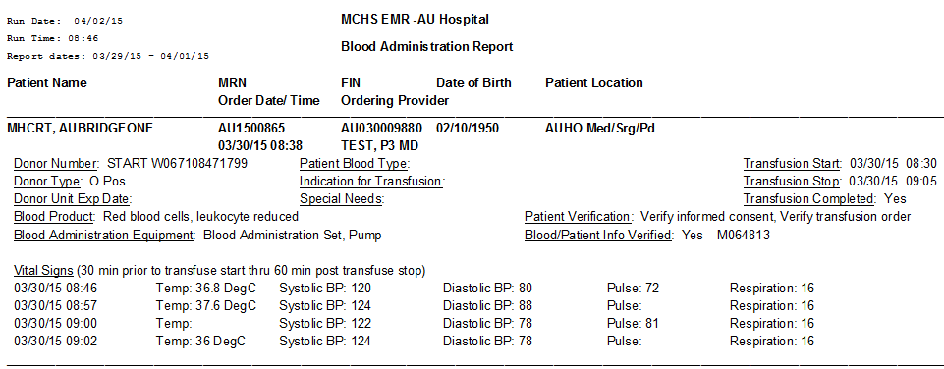

|  |  |  |
| --- | --- | --- |
| **Data Element** | **PowerForm** | **Bridge** |
| Patient Name | PowerChart | PowerChart |
| MRN | PowerChart | PowerChart |
| FIN | PowerChart | PowerChart |
| Date of Birth | PowerChart | PowerChart |
| Patient Location | PowerChart | PowerChart |
| Order Date/Time | Transfuse Order | Transfuse Order |
| Ordering Provider | Transfuse Order | Transfuse Order |
| Donor Number | Donor Number (Free-text) | **Scan. Donor Number** |
| Donor Type | Donor Type (Radio Buttons) | **Scan. Donor Type** |
| Donor Unit Exp. Date | Blood Unit Expiration Date/Time (Date/Time Field) | **Scan. Blood Exp. Date** |
| Blood Product | **Blood Product (Multi-select)\*** | **Scan. Blood Product** |
| Blood Administration Equip. | Blood Administration Equipment (Multi-Select Field) | Equipment  (Multi-Select Field) |
| Patient Blood Type | Patient Blood Type  (Radio Buttons) | Pulled from PowerChart |
| Indication for Transfusion | Indications for Transfusion (Radio Buttons)  **DTA** **To be removed** | **Not Captured** |
| Special Needs | Special Needs (Radio Buttons) | **Not Captured** |
| Transfusion Start | **Transfusion Start Time**  **(Date/Time Field)\*** | Blood Unit Transfusion Start Time. |
| Transfusion Stop | **Transfusion Stop Time**  **(Date/Time Field)\*** | Blood Unit Transfusion Stop Time |
| Transfusion Complete | **Transfusion Completed**  **(Radio Buttons)\*** | **Not captured** |
| Patient Verification | Patient Verification  (Multi-Select Field) | **START: Consent, Order Verify \*** |
| Blood/Patient Info Verified | **Blood and Patient Information Verified (Yes button)\*** | **Not Captured** |
| Vital Signs | Standard V/S tab | **Required** |

**\* Required Field**